[1]

Real-Time Implementation of a Flexible, Synchrophasor-based Wide-Area Damping Control System

Eldrich Rebello, *Non-Member, IEEE,* Muhammad Shoaib Almas, *IEEE Student Member,* and

Luigi Vanfretti, *Senior Member, IEEE*

*Abstract*—The modern power grid is increasingly being used under operating conditions of increasing stress for which it was not designed, giving rise to grid stability issues. One of these stability issues is the phenomenon of low frequency, electro- mechanically induced, inter-area oscillations. Simulations have demonstrated the advantages of Wide Area Measurement Signals (WAMS)-based Power Oscillation Damping (POD) in achieving improved electromechanical mode damping compared to traditional, local signal based, Power System Stabilizers (PSS). This work takes a Phasor-based oscillation damping algorithm and deploys it on a National Instruments real-time controller. The developed prototype is tested in a real-time Hardware-in-the-loop approach (RT-HIL) using OPAL-RT’s eMEGASIM real-time simulation platform and synchrophasor data from real PMU’s. It is demonstrated to have applications independent of the controlled device. Challenges faced, the solutions implemented together with the present prototype’s limitations are also discussed

*Index Terms*— WAMPAC, WAPOD, synchrophasor, PMU, damping control, Wide Area measurement and control

# INTRODUCTION

T

HE goal of this paper is to demonstrate both the potential and flexibility in oscillation damping controller design that is possible by using synchrophasors (C37.118). The Phasor Power Oscillation Damping (Phasor POD) algorithm originally developed by Ängquist and Gama [1] is implemented and run on a National Instruments Compact Reconfigurable Input / Output (cRIO) real-time controller. A modified, SIMULINK model of the four-machine, two-area network developed by Klein-Rogers and Kundur [2] is executed in real-time on the eMEGASIM [3] platform from OPAL RT. A Hardware-in-the-loop (HIL) test is set up to verify the performance of the hardware implementation of the Phasor POD algorithm. The flexibility of the developed controller is also demonstrated by extracting various data from the synchrophasor input and using each as a damping input to the controller. This paper also illustrates that the controller can have multiple applications is demonstrated by testing it with two different controlled devices; a generator AVR system and a FACTS-device excitation system.

## Motivation

Although the purpose of system interconnection was to increase stability, the present situation of the power system incorporates renewable energy sources and power trading corridors, both of which impact system stability. More modern solutions to the problems of inter area and intra oscillations use Power System Stabilizers (PSS) [4]. While a PSS provides excellent damping to intra area modes with good local observability, its performance with inter-area modes may not be satisfactory [5].

## Literature Review

Analytical studies and tests. One test from China and one from Norway.

## Paper Contribution

## Paper Organization

This paper is organized as follows:

Section II presents a brief background of the work along with the details of Phasor based power oscillation damping algorithm.

Section III covers the hardware and software architectures implemented for phasor POD.

Section IV covers the preparation of the test case power system models developed in MATLAB/Simulink for real-time hardware-in-the-loop evaluation of the hardware POD. Two test cases are examined, one with the WAPOD input fed to the excitation system of a Static VAR Compensator (SVC) and the other with the WAPOD modulating the input of a generator’s Automatic Voltage Regulator (AVR).

The results obtained from the two tests are presented and analysed in Section V.

Section VI examines some of the major challenges and problems faced in the development, implementation and testing of this WAPOD controller including software challenges and the difficulties faced when dealing with real-world, analogue signals compared to pure simulations. Finally the conclusions are drawn in Section-VI along with the roadmap for the future work.

# Background

As modern power systems grow in size, both in terms of power transfer capacity and geographic spread, they are increasingly being used for purposes that they were not designed for. Examples of these ‘new’ uses include conditions of increasing stress such as power trading between countries. These interconnections, which link synchronous generators, often separated by vast physical distances, create conditions where small disturbances can excite oscillations that may or may not settle. When the generators of one area oscillate at a low frequency (typically 0.2–2.5Hz) against the generators of another interconnected, but distinct area, ‘inter-area’ oscillations may be excited.

One of the approaches for generating command signals for damping is called phasor POD proposed in [15]. The principle for creating the damping signal using the Phasor POD approach is shown in Figure 16. The main objective is to separate the oscillatory part of the input signal from the average value. The oscillatory part of the measured input signal is extracted as a phasor by using either recursive least square estimation technique or a low pass filter. The damping signal is computed by applying appropriate phase shift on the extracted oscillatory signal phasor [15]. This damping signal is provided as one of the inputs to the excitation control of FACTS devices. The Phasor-POD algorithm essentially separates an input signal into an average valued and an oscillating component. The oscillating component when suitably phase-shifted can be used as a supplementary damping input to a generator’s AVR or the excitation system of a FACTS device.

**Equations for Phasor POD with Explanation**



Fig. 1. Operating principle of Phasor POD and generation of control signal for SVC to provide power oscillation damping.

One important reason for choosing the Phasor-POD algorithm for real-time implementation was the fact that the algorithm uses few inputs and is independent of network configuration and topology. The only algorithm parameter that is network-dependent is the oscillation frequency and this is usually known from system studies or can be determined directly from synchrophasor measurements (**citation** here). Compared to conventional, linearisation-based controllers, the adoption of phasor-based controllers has not been high mainly due to the fact that such controllers tend to be highly non-linear and thus difficult to model in simulation studies [16].

# Software Architecture and Hardware Configuration of Developed POD

## Software Architecture of Prototype POD

LabVIEW’s Real Time and FPGA modules were used to write the code for the respective sections of the cRIO. Also, since no synchrophasor data-extraction software was capable of running independently on the RT controller, the process of extracting raw measurement data from the synchrophasor data stream was performed on a desktop computer. The software used for this was identical to that in [15] and would run on a workstation computer, extract data from the PMU stream and send this extracted data to a LabVIEW program running on the same computer [15].

A three-layer, modular code architecture, based on an avail- able template [14] was selected for implementation. An outline of the architecture is shown in Figure 2 and each of the three layers are outlined below.

* + Core FPGA Software : Interacts with hardware terminals for I/O and runs Phasor-POD algorithm
  + Real Time (RT) Software : Manages network communication to remote terminal and also generates perfor- mance monitoring data
  + Remote Interface: Runs on workstation computer: Used to update algorithm parameters and monitor data & performance. This layer is non deterministic.

The Phasor-POD algorithm could be implemented on either the real-time section of the cRIO or the FPGA but was implemented on the FPGA. This decision was made keeping in mind the computational resources and response speed needed to match the step size of the real-time simulator. The complexity of the code meant that the cRIO’s real-time controller would not be able to complete an iteration of the algorithm in the required 50µs response time. The real-time section of the cRIO handles network communication. Its primary purpose is to receive measurement data that the workstation computer extracts and to stream this data to the Phasor-POD algorithm running on the FPGA. The real-time controller also handles commands coming from the user interface running on the workstation computer. It also monitors the output of the FPGA, sends data to the user interface for monitoring, periodically logs input and output data and handles error conditions. The remote interface runs in LabVIEW on a conventional Windows can be controlled from this interface. Also, the algorithm parameters can be set and modified. Since the operating system here is not real-time but is multi-tasking, the execution speed depends on the processor load and is not deterministic. Statnett’s Synchrophasor Software Development Kit (S3DK) was used to unwrap the PMU streams coming from the PDC and extract phasor measurements [15]. This allowed for data to be extracted and used directly in the LabVIEW environment. Since the PMU reporting rate was 50 messages a second, new data was available every 20ms. The loop rate used by the S3DK was hence 20ms. The selection of a input for the controller and the computations required are performed here. For example, if active power is to be used as a POD input, voltage and current values must be multiplied to obtain the active power. If the voltage angle difference is to be used as an input, the required calculations are performed in this VI.



Fig. 2. Labview 3 layer architecture

Write about the front interface (the remote VI), monitoring, explain the different indicators in the front panel. Don’t go into too much details. I have added the plot of FFT (o.64 Hz), plot for Active Power transfer etc. Explain how we can select different input signals blab la bla by referring to the front VI



Fig. 3. Labview 3 layer architecture

## Hardware Configuration of Prototype POD

Describe the modules by referring to the diagram below. Mention that cRIO is communicating with the remote VI (Host VI) through Ethernet. Modules I/O are controlled by FPGA. Which module etc.



Fig. 3. Labview 3 layer architecture

## Test Case Model for Evaluation Performance of POD

## Scenario 1: Two-Area Model Preparation - FACTS Device

Only put the detail of the 2 area system and the addition of SVC in the middle which will receive the POD signal from the NI-POD.

The second application in Figure 4 is to use the WAPOD output as a modulating input to an SVC’s excitation system. The two-area model was prepared for simulation in the same way as in the previous case except that the PSS at each machine was included. The SVC model used was an average valued model, identical to that used in [6]. The SVC was connected at the mid-point of the two area network. As proved by Chow and Larsen in [10], this is the point where voltage swings will be the greatest and also where the SVC two parallel and identical implementations of the Phasor-POD algorithm were used, one implemented in SIMULINK and the other on the cRIO. Either could be switched in at a given time. It is important to note here that when the hardware- POD algorithm was switched in, the PSS’s at each of the four machines were disconnected, leaving the SVC as the sole control and damping device in the network. The ability of the SVC to keep the network stable and also to restore it to stability was verified with an off-line simulation using the Phasor- POD implemented in SIMULINK. Also, the performance of the PSS’s were not degraded as the Phasor-POD algorithm would not be running in parallel with them.



Fig. 6. Klein-Roger-Kundur two area, 4 machine test system with SVC in the middle. In the first scenario, the hardware prototype POD is configured to provide damping control signals to the excitation control of an SVC

In this study an average model of SVC is developed in MATLAB/Simulink which exhibits the behavior required for small signal stability analysis. The model developed is shown in Figure 13. The voltage error signal at the mid-point is fed to a PID controller which provides a value of the susceptance (BSVC) of the SVC. This susceptance is used to compute three phase current which is injected at the SVC’s point of connection to increase or decrease the voltage at the bus. 

Fig. 7. Average model of SVC developed in MATLAB/Simulink and coupled at the midpoint of the 220km long transmission line of the test case system.

* 1. Scenario 2: *Two-Area Model Preparation - Generator AVR*

Only explain the modification which you are now doing for sending the damping signal to the AVR of generator.

The two-area network [2] is known to be unstable without external damping control. The difference between the rotational inertias of two of the machines, in an otherwise symmetric network gives rise to the 0.64Hz inter-area mode. The SIMULINK model used here implements damping control using a supplementary signal generated from a PSS and applied to the excitation system of each of the machines to achieve steady-state stability and also to damp out the inter-area mode. This model was modified to have a damping control system only at Machine M1 in Area-1 (see Figure 4).



Fig. 4. Scenario 2 for testing hardware POD capability to provide damping signals to the AVR of the Generator. Only Area 1 of the test case system is shown here.

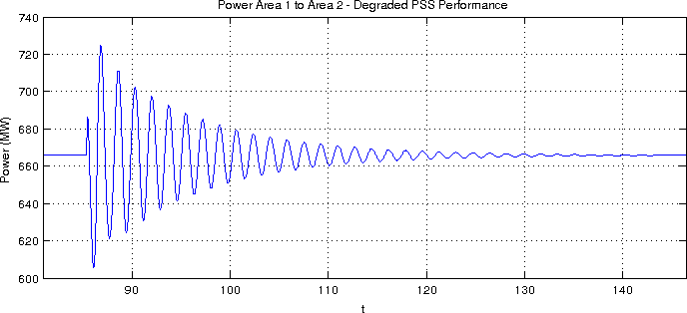

Fig. 4. Degraded performance with PSS.

All other machines have their PSS’s disconnected. This configuration was verified to be able to both achieve stability and to be able to restore the system to stability after the application (and subsequent clearing) of an 8 cycle, three- phase to ground fault. The original model uses a PSS tuned to achieve maximum damping, given the operating conditions.

To demonstrate a potential application scenario for the developed POD prototype, the performance of the PSS is degraded so that it is still able to provide damping but takes substantially longer (Figure 3). This figure shows the system response to a 200ms perturbation in the voltage reference of machine M1. Note that under the action of the sole PSS at machine M1, the inter-area mode is damped and the system is restored to stability. This mimics a real-world situation where an already installed PSS whose performance has degraded over time due to changing network conditions or poor tuning.

## Overall Testing

Explain the whole loop here referring to figure below. Explain all these 1-6 steps. Like (3) are the amplifiers to amplify current and votlages to 1 A and 100 V respectively etc (just mention SEL PMUs here) No need to show cRIO PMUs.

The modified network in each case was grouped into sub- systems and prepared for simulation in RT-LAB. The simu- lation time step chosen was 50*µ*s. Outputs and inputs of the real-time simulator would be updated every 50*µ*s. Current and voltage measurements were taken from the points marked in Figure 4 and were extracted from the analogue outputs of the real-time simulator. The damping signal *dVpod* in Figure 4 was generated at two points; one in the real-time simulation itself using a Simulink implementation of the Phasor POD algorithm and one externally on the cRIO. Both signals were generated simultaneously and either one could be switched in for use in the simulation.



Fig. 4. Scenario 2 for testing hardware POD capability to provide damping signals to the AVR of the Generator. Only Area 1 of the test case system is shown here.

# Testing and Results

Testing the operation of the hardware prototype involved us- ing the HIL3 setup outlined in Figure 1 and verifying whether steady state stability could be maintained in the simulated two- area network. Once this was demonstrated, the inter-area mode was excited by changing the voltage reference *Vref* of Machine M1. The oscillations caused by this disturbance would then be damped out by the PSS in tandem with the Phasor POD algorithm. The POD algorithm implemented in SIMULINK uses the locally available active power measurements as input. In the case of the Generator PSS, this is the active power measured at the terminals of the generator. In the case of the SVC, the active power at the mid-point of the interconnecting line (also the point of connection of the SVC) is used as an input. The WAPOD prototype is also able to use this same signal as input in each case but can also exploit other data contained in the synchrophasor data stream.

1. *SVC Excitation Supplementary Input*

Figure 5 illustrates the response of the hardware controller to a small disturbance at machine M1. This disturbance is a 5% change for 200ms in the reference voltage of the AVR. This is sufficient to excite the inter-area mode. The best damping performance is achieved using voltage angle difference as a damping input to the Phasor-POD algorithm. This supports the theoretical results predicted by Chompoobutrgool and Vanfretti in [11]. A frequency analysis of each of these responses shows voltage swings will be the greatest and also where the SVC can be most effective at damping power swings As before, that the dominant mode in each response is the 0.64Hz inter- area mode. This is evident in Figure 6, which presents the magnitude spectrum of the controller response with voltage angle as input.

Figure 5 illustrates the response of the hardware controller to a small disturbance at machine M1. This disturbance is a 5% change for 200ms in the reference voltage of the AVR. This is sufficient to excite the inter-area mode. The best damping performance is achieved using voltage angle difference as a damping input to the Phasor-POD algorithm. This supports the theoretical results predicted by Chompoobutrgool and Vanfretti in [11]. A frequency analysis of each of these responses shows voltage swings will be the greatest and also where the SVC can be most effective at damping power swings As before, that the dominant mode in each response is the 0.64Hz inter- area mode. This is evident in Figure 6, which presents the magnitude spectrum of the controller response with voltage angle as input.

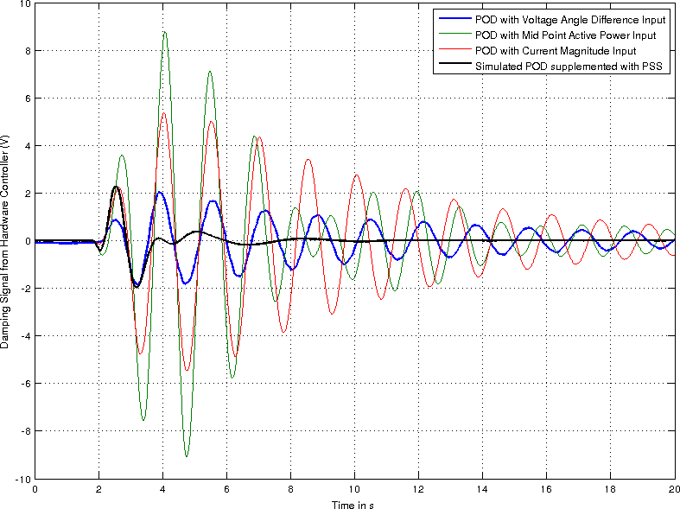

Fig. 5. Controller Response Comparison : Supplementary SVC Excitation Input

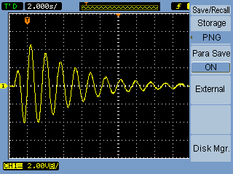

Fig. 7. Controller Response with Voltage Angle Difference input Captured on Oscilloscope

1. *Generator Excitation Supplementary Input*

The controller response to a small disturbance when operat- ing in tandem with a degraded PSS is shown in Figure 8. It is evident that the combination of the WAPOD and the PSS is significantly better than the PSS alone in every case. It can also be noted that the shape of the response shows a significant deviation from that in Figure 5, where the dominant 0.64Hz mode is clearly visible. Also evident from Figure 8 is the fact that the damping performance of the WAPOD changes significantly as its input is changed. Using the voltage angle difference as input provides the best performance. The performance with the simulated POD algorithm is not shown in Figure 8 for clarity,the performance of the WAPOD with the voltage angle difference input is very close to the performance of the simulated POD algorithm that uses active power as input. This performance is achieved despite the presence of a stochastic time delay and noise in the input measurements

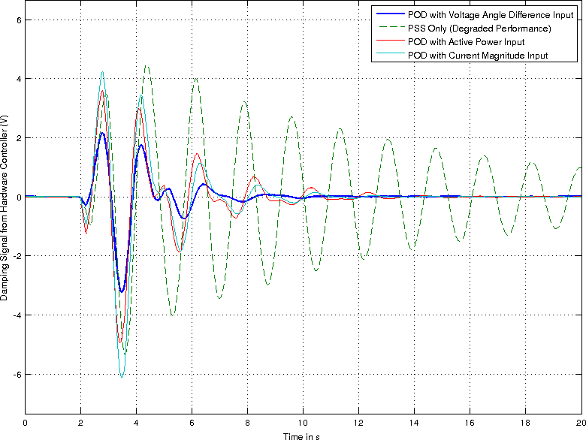

Fig. 8. Controller Response Comparison : Supplementary Generator Excitation Input

of the WAPOD. As in the case with the SVC, the theoretical results in [11] agree with the experimental results.

# Challenges

## Time Delays

The Phasor POD algorithm running in SIMULINK has close to zero time delay between network behaviour changing and the controller responding. The same algorithm, when run on the cRIO, receives data with a stochastic delay. Figure 1 illustrates the complete data path and from this, it is evident that several sources of time delay exist. Sections such as the analogue amplifiers, the FPGA execution speed (a constant 50*µ*s), the real-time section of the cRIO and the PDC all represent fixed, non-zero time delays. Sections such as the D/A and A/D conversion in the real-time simulator also add a deterministic time delay. However, sections of the data path such as communication over a TCP/IP network and the PC used to extract raw measurement data from the synchrophasor stream all represent variable delays. These delays all contribute to a delayed response from the cRIO. This delay allows for a network disturbance to grow slightly before the cRIO starts responding. It also has the effect of changing the phase compensation required in the Phasor-POD algorithm. Though the delay cannot be compensated for, the phase compensation needed can be changed depending on the measured delay. Presently, the phase compensation required is determined iteratively though this can be automated using time-stamped data.

Write about end to end time delay (heartbeat signal) and make a table here with value available in your thesis. Explain the tie delay sources by referring to this figure below.



Fig. 5. Controller Response Comparison : Supplementary SVC Excitation Input

## Analog Limits and Noise

The original POD (Phasor Oscillation Damper) algorithm [1] was developed and simulated in an ideal, noise-free environment with zero delay. More importantly, no limits are imposed on the magnitude of either the controller’s inputs or outputs when it is simulated. In contrast, a hardware-based implementation that uses analogue signals is constrained by the analogue signal magnitude limits.

Consider the analogue outputs of OPAL RT’s eMEGASIM simulator [7]

* + **Analogue Outputs** : Number: 32 (+/-16V and +/-10mA)
  + **Analogue Inputs** : Number: 128 (+/-100V and +/- 10mA)

These are low level outputs and can be directly connected to the PMU inputs. However, the inputs modules of typical PMU’s are rated for 0-300V and a 0-16V analogue signal will not use a significant portion of this range. Additionally, a signal of such a small magnitude will be contaminated by noise and will consequently have a poor Signal to Noise ratio. A similar argument can be made for the current outputs.

The output of the simulated POD can vary over several orders of magnitude, ranging from 105 at times of peak damping to as small as 10*-3*once the oscillation magnitude becomes small. It is difficult to accurately recreate analogue signals with such vast dynamic ranges. The voltage output module used with the cRIO here had a 24-bit resolution and was limited to 10V in magnitude. Any values generated by the POD algorithm that were greater in magnitude that 10V would cause output saturation. All these issues meant that signal magnitudes had to be amplified in certain cases to use the full measurement ranges or had to be limited in other cases, so as to capture variations without saturation.

## Loop Rates and FPGA Resources

The most significant challenge in the real-time implemen- tation of the Phasor-POD algorithm was the fact that different sections of the hardware control loop run at different loop rates or step sizes. Added to this was the fact that the real- time simulator generated data every 50*µ*s and thus expected data from the HIL setup at the same rate while the rest of the HIL setup did not support such a high data rate. The PMU’s used supported a maximum data reporting rate of 50 samples/second. Table I lists the different components of the HIL setup together with their respective loop rates 50*µ*s was chosen for the FPGA loop rate in order to match the loop rate of the real-time simulator. This was to ensure that data was always available at the analogue input of the simulator and no erroneous data points were read. The 50*µ*s loop rate of the FPGA meant that new data was expected every 50*µ*s, corresponding to a 2000s/s sampling rate. The fastest execution speed of the real-time section of the cRIO was 1ms, significantly slower than the FPGA’s speed. New synchrophasor data was available from the PMU’s only every 20ms. One solution to this problem was to upsample the synchrophasor data, interpolate between consecutive data points and then stream this data to the Phasor-POD algorithm on the FPGA. A FIFO buffer would be used to buffer the data generated by the up-sampling process as it was gradually consumed by the FPGA. The major problem with this method was that the up-sampling process on the RT controller is computationally intensive and would not run at the required 20ms loop rate.

An alternative solution would be to implement a sample and hold algorithm on the FPGA. As data was extracted every 20ms, the RT controller would receive this data and send it to the FPGA. This value would then be held constant till the next data point arrives. This was implemented and found to work satisfactorily. In essence, the only difference between the Phasor-POD algorithm running the SIMULINK and that on the cRIO was the data rates of their input data. The simulated POD received new data every 50*µ*s while the cRIO-based POD received data every 20ms simulation.

# Conclusion and Future Work

This work has demonstrated the feasibility of using wide area power system data in the design of an oscillation damping controller. The generic nature of the developed controller was demonstrated by using an identical implementation with mere changes in paramaters to suit the controlled device’s input requirements and capabilities. The performance of the WAPOD can be improved by exploiting the full range of data available in a synchrophasor data stream.The flexibility of synchrophasor data was demonstrated and the wide range of inputs possible from this were also tested. The results from this work serve as a proof-of-concept to what?

The WAPOD prototype as developed in this work demon- strates the possibilities of using wide area synchrophasor data for damping control. The prototype here is, however, dependent on manual input for signal selection and algorithm parameter values. These two processes can be automated by having the WAPOD itself monitor the various input signals and intelligently select the one having the highest observ- ability of a particular mode. The algorithm parameters can also be determined adaptively on the WAPOD itsef. On the same lines, this can further be extended to include selection among several measurement locations on the network. The fact that a stochastic time delay is introduced by unwrapping the synchrophasor data stream on a desktop computer can be addressed by performing this function on the WAPOD controller (here, the cRIO) itself.

ACKNOWLEDGMENT

M.S. Almas is supported by the STRONg2rid project, funded by Nordic Energy Research.

L. Vanfretti is supported in part by the STRONg2rid project, funded by Nordic Energy Research, by the STandUP for Energy collaboration initiative and the KTH School of Electrical Engineering.

The generosity of Schweitzer Engineering Laboratories, Pullman, WA, USA; for their donation of protection relays, and Megger/Programma, Täby, Sweden; for their donation of different hardware and technical support is deeply acknowledged.

REFERENCES

[1] L. A¨ ngquist and C. Gama *Damping Algorithm based on Phasor Estima- tion* in Power Engineering Society Winter Meeting, 2001. IEEE, Volume 3, pp. 1160 - 1165

[2] M. Klein, J. G. Rogers and P. Kundur *A fundamental study of inter-area oscillations in Power Systems* IEEE Trans, PWRS, no. 6, pp. 914-921, 1991.

[3] *eMEGASIM Power Grid Real-Time Digital HArdware in the Loop Simulator* Available Online at : <http://www.opal-rt.com/>

[4] F. P. Dmello, and. C. Concordia *Concepts of Synchronous Machine Stability as Affected by Excitation Control* IEEE TRANSACTIONS ON POWER APPARATUS AND SYSTEMS, vol. PAS 88, no. 4, 1969.

[5] M. E. Aboul-Ela, A. A. Sallam, J. D. McCalley and A. A. Fouad, *Damping Controller Design for Power System Oscillations Using Global Signals*, IEEE trans. on Power Systems, Vol. 11, No. 2, May 1996, pp. 767-773

[6] M. Shoaib Almas and L. Vanfretti, *Implementation of Conventional PSS and Phasor Based POD for Power Stabilizing Controls for Real-Time Simulation*, IEEE IES IECON14, 29 Oct-1 Nov, 2014, Dallas, USA.

[7] eMEGAsim PowerGrid Real-Time Digital Hardware in the Loop Simu- lator Opal RT, [Online]. Available: <http://www.opal-rt.com/>

[8] N.S. Chaudhuri, R. Majumder and B Chaudhuri *Interaction between conventional and adaptive phasor power oscillation damping controllers* in Power and Energy Society General Meeting, 2010 IEEE Minneapolis,

MN, 2012 pp. 1-7

[9] L. Vanfretti.; M. Chenine; M.S. Almas; R. Leelaruji; L. Angquist;

L. Nordstrom, ”*SmarTS Lab A laboratory for developing applications for WAMPAC Systems*,” Power and Energy Society General Meeting, 2012 IEEE , vol., no., pp.1,8, 22-26 July 2012

[10] E.V Larsen and E.H Chow, General Electric Company, NY, *Application of Static VAR Systems for System Dynamic Performance*, 1987 IEEE pp. 43-46

[11] L. Vanfretti, Y. Chompoobutrgool, and J.H. Chow, *Chapter 10: Inter- Area Mode Analysis for Large Power Systems using Synchropha- sor Data*, Book Chapter, in Coherency and Model Reduction of Large Power Systems, Joe H. Chow (Ed.), Springer, 2013. Avail- able Online at [http://www.springer.com/energy/systems%2C+storage+](http://www.springer.com/energy/systems%2C%2Bstorage%2B) and+harvesting/book/978-1-4614-1802-3

[12] *Operating Instructions and Specifications Compact RIO NI cRIO- 9081/9082*, National Instruments, Available Online at <http://www.ni.com/> pdf/manuals/375714a.pdf

[13] *Operating Instructions and Specifications Compact RIO NI cRIO- 9075/9076*, National Instruments, Available Online at <http://www.ni.com/> pdf/manuals/375650b.pdf

*FPGA Control on Compact RIO Sample Project Documentation*, Na- tional Instruments, Available Online at <http://www.ni.com/white-paper/> 14137/en/

[15] Vanfretti, Luigi and Aarstrand, Vemund H. and Almas, M. Shoaib and Peric´, Vedran S. and Gjerde, Jan O. , *A Software Development Toolkit for Real-Time Synchrophasor Applications*, IEEE PES Grenoble PowerTech, 2013

[16] N.S Chaudhuri, R Majumder and B Chaudhuri , *Interaction between conventional and adaptive phasor power oscillation damping controllers* in Power and Energy Society General Meeting, 2010 IEEE Minneapolis,

MN, 2012 pp. 1-7

[17] I Kamwa *Performance of Three PSS for Interarea Oscillations* Sim-

PowerSystems Examples, MATLAB R2011a

[18] *Generic Power System Stabilizer* Documentation distributed with MATLAB R2014a Available online at <http://www.mathworks.se/help/> physmod/sps/powersys/ref/genericpowersystemstabilizer.html

1. Eldrich Rebello has completed his Master’s degree the School of Electrical Engineering, Aalto University, Helsinki, Finland e-mail: eldrich.rebello@aalto.fi

   M. Shoaib Almas and L. Vanfretti are with KTH Royal Institute of Technology, Stockholm, Sweden. Email: msalmas@kth.se, luigiv@kth.se

   This project was supported in part by the Nordic Energy Research through the STRONg2rid project.